**CHAPTER 1**

**INTRODUCTION**

**1.1 Introduction:**

Nowadays, the uses of internet are available and almost cheap. It’s a global system which is interconnected through computer or such like devices using the Internet protocol suite (TCP/IP)[web log post]. File sharing is an example of transferring large amounts of data across the Internet. As it’s an era of computer and many more gadgets (Bailey, 1954).A person always thinks of easiness of their regular works by using internet. Being a developed country, many of us are in our country using mobile phone especially smart phone. So a system is going to be established where the interaction of doctor and patient will increase through these smart phones/gadgets through internet, mostly known as online. Enhancing patient care management is one of the major aims of healthcare industry today to improve the healthcare system worldwide. This goal is to be equally if not more important as the other keys of improving the health of the population and managing per capita cost of care. Now making this issues as an aim, the emphasis will be given on getting appointment of doctors through an online based system for patients easily, having previous profile and different test result of a patient with the help of a cloud based systems, a most nearby doctor through GPS and the density of patients of particular disease in a particular place (Mardiah, F. and Basri, M. (2013)). A system where all the data for both doctor and patient, will be stored, so that both of them can contact with each other at anytime, from anywhere by getting the necessary data.

A system is going to be developed for a proper solution of these problems, which will be called **“Easy Medical System Service (EMSS)”**. A fully online service most of these features are automated, slightly manual.

The proposed project is a system that provides patients as well as doctors an easy way to communicate with each other. Moreover we focus on lessening the woe of patients by finding a specialist, clouding their reports and swiftly access to a nearby doctor, finding a specialist doctor also. A doctor can also find the density of patients of particular disease so they can go for help in instance.

**1.2 Present Situation:**

Nowadays People go to the clinics or hospitals and take appointments of doctors; even they don’t get information of nearby doctor. It is rational to establish the fact that, very few hospitals provide online scheduling doctor-patient session. For first aid they go to their known doctors whether there may be a doctor who is in much nearer (NIMS Institute of Management & Computer Sciences, (n.d)). Sometimes there is huge patient of a particular disease in a remote area, and they can’t come to the doctor and the nearby doctor doesn’t know anything about that. Again the reports of patients are lost sometimes which is so much irritating. Moreover many patients are unknown to a new specialized doctor (Gupta & Denton, 2008). Though there’s some website of some medical but most of them can’t access through mobile.

**1.3 Objectives:**

* To develop automated doctor appointment service for each and everyone’s hand in the form of web based system.
* To reduce the sufferings of patients or his/her kith and kin while getting the appointment.
* To save time by getting the appointment in online and also for getting available information of a doctor.
* To create a location based doctors information directory service and the users are able to get the appointment of required doctors.
* To find a doctor to the nearest location with GPS system.
* To help the people of remote area who can’t go the doctors in a regular basis by mentioning a particular place where the density of a particular disease has increased in an epidemic from.

**1.4 Organization:**

During the development of this project we have used **SDLC**, System Development Life Cycle model, among the available models for developing a project. Here we organized our project in the following pattern:

**Chapter 2** includes the analysis of the situation of present system for doctor’s appointment, different present system applications.

**Chapter 3** includes instruction to the proposed system, advantages, proposed information flow and functional components about the Proposed System.

**Chapter 4** traces Structured Analysis with the tools such as Use case diagram, Data flow diagram or Bubble chart, E-R diagram, Data dictionary, Activity diagram,, State diagram, and so forth.

**Chapter 5** includes partial Implementation and Testing with some snapshots of the proposed system.

Finally, **Chapter 6** describes Conclusion and gives suggestion for further expanding of the proposed system.

**CHAPTER 2**

**LITERATURE REVIEW**

**2.1 Introduction:**

At present in Bangladesh doctors’ appointment system is totally manual. To book of a doctor appointment a patient has to go to the doctors’ clinic first. Then he/she has to take an appointment from the receptionist or doctor’s assistant. Now a day in many cases this procedure can be done by a phone call to the assistant. Sometimes the phone number found switched off or busy for a long time. Patient has to suffer a lot to make an appointment of his/her desired doctor. Again, storing the test report is also very tough in this busy life. Moreover, finding a specialist nearby place is tough (Idowu, A., Adeosun, O. and Williams, K. (2014)). Doctors are quite unknown about the epidemic form of various diseases. As we live in the world’s most populated country, all of this crankiness makes a hazard. So it’s more felt to do something in this arena.

**2.2 Currently available system:**

The existing system consists of booking a doctor’s appointment through different websites. There are a few automated systems in our country. We’ll go through the working systems presently available.

**2.2.1 RX71:**

Rx71.co is a Bangladeshi website that provides the directory of doctors and hospitals all over the Bangladesh. This website provides services based on different types of information related to health. Services provided by rx71.co are:

* Helps to identify the nature of an illness or other problems according to the symptoms.
* Provide health tips.
* Hospital Directory
* Doctors Directory

Website:  **http://rx71health.com/**

**2.2.2 Doctorola:**

Doctorola is a new online website and call center based service for medical help seeker. This is mainly a doctors directory by which people can find doctor of different locations by searching from the directory and anyone can make an appointment with their desired doctor by calling Doctorola hotline 09-606-707-808 (08am-10pm) or visiting the websiteanytime**.** Though people can make appointment from this website, but ultimately it is not a fully automated system.It’s some features are attractive. This system has own blog where the top rated health related topics are written, there’s a FAQ system though it’s not working now, a doctor is always in online for giving the first aid.

Website: **https://doctorola.com/**

**2.2.3 Practo:**

**Practo** is a website that is very useful as it provides various features. The appointment confirmation is given by a sms. The main drawback of this system is that, it is a website and one requires a very good internet connection as loading of web pages may take a long time. Along with this, there is another android app available on playstore but it is a paid app, hence everyone cannot afford to use it.

Website: **https://www.practo.com/**

**2.2.4 BDMER**:

This is the first ever site that was fully automated with cloud system in Bangladesh. Patient can easily cloud his data here having a privacy pin. Only with the pin a doctor can see the details report of a patient. Whereas a doctor can watch any immediate test report, he can also prescribe in online with patient directly. A patient can store his sugar level, blood pressure, pulse rate, weight, height, BMI etc. In which test the lab reports have to be submitted such as X-Ray, ultrasound, CT scan, MRI, Biopsy etc are directly send from hospital/diagnostic lab. It provides all these both in website and in apps.

Website: **https://bdemr.com/**

**2.3 Summary:**

Most of the websites provide only information about the doctors. Although some websites help to find doctors and book an appointment through phone call to hotline numbers they provided, they do not provide any automated appointment booking system (Cayirli & Veral, 2003). The doctors don’t get any information how much patients are coming in a particular day. Not even the doctor can know any epidemic form of any particular place. The whole world is getting closer day by day. We all have mobiles or gadgets which are connected with internet. Having this opportunity we cannot use this fruitfully which is a matter of sorrow (Dai, X. (2013)).

**2.4 Information Flow Diagram of Present System:**

According to the analysis of present system the information flow of the present system can be expressed by the following diagram of figure:

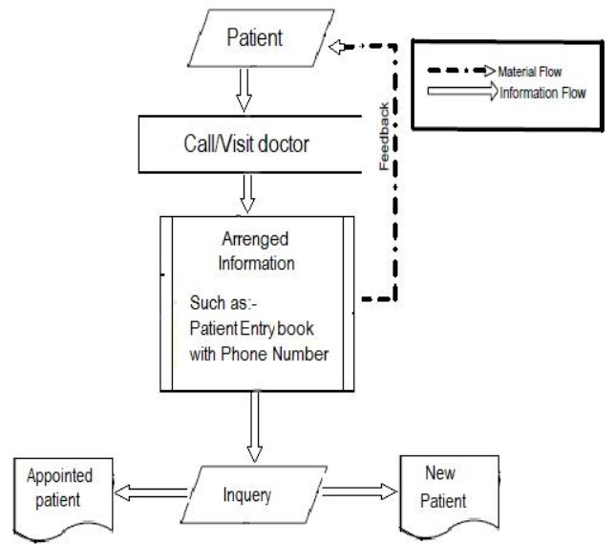

FIGURE 2.1: Information Flow Diagram of Present System.

From this flow diagram we can easily assume that the total appointment system is too much pathetic for a patient and his fellows also .Everything is manual and there’s no direct connection between doctors and patients before they meet. Here a proper developed system is needed a that system is going to be developed.

**CHAPTER 3**

**PROPOSED SYSTEM**

**3.1 Introduction:**

Observing the present system and all these websites and apps we came to a decision that the existing systems have some drawbacks. Some of the major drawbacks are listed below:

* Most of the systems are fully manual
* Most of them provide only the information
* They do not provide automatic booking appointment method
* They can’t say the density of a particular disease in a particular place
* Categorized doctors can’t search

To overcome these drawbacks we need to develop the proposed system, **EMSS (Easy Medicle System Service)**.

**3.2 Description of Proposed System:**

The proposed system is designed for two types of user-Doctor and Patient. The users will first have to download the application or have to go to our particular websites. After installing it or going to our website, the users both doctors and patients will have to register into it for the first time by filling up a registration form as a doctor or as a general user (Abd Wahab, M., Hassan, N., Wali Mohd, Z. and Hanaf, H. (2009)). The registration form contains Name, Username, Email and Password fields. The user can use this username and password for logging into his profile.

By logging in as a doctor, one can specify his/her information, BMDC Reg. No, specialized area, address, clinic where he practices, schedule of watching patients, phone, email and other information that helps a patient to find him/her easily (Mypatientscheduler.com. (2016)). Moreover a doctor can see patient’s previous report and prescription if those are available in patient’s profile. Also can see how much patients he has to see today.

Client side is required to have internet access to connect with web server and application of appointment automation system. (EssayMonster.net - essays, research papers, dissertations & etc. (2016)) By logging in a as a patient, the patient also have to give some information, his/her name, his/her previous prescription/any test report (If any), address, phone , email and other information that helps a doctor to understand the present condition of him/her. Patient can search a doctor by name, specialty, address field or any of them. After selecting the filtration type, the doctors list will be displayed. The patient can select any particular doctor and view his profile. Also the patient can view the doctor’s schedule and look for an appointment according to the date that the doctor allows to take advance appointment. The patient can see the serial number of a particular date and the appointment will be fixed after patient will confirm it.

**3.3 Advantages of Proposed System:**

The proposed system surely has some advantages including fast and easy way to find a doctor and also booking an appointment of desired doctor with less time. Again doctors can see the epidemic situation of particular place. The other features of this project which will bring straightforwardness to our daily life.

* This system will help to reduce the waiting time of the patient.
* The proposed system will allow the freedom to choose from a vast doctor database and approach a specialist near their home.
* A doctor can follow up a patients log at anytime from anywhere.
* Epidemic form will endanger.
* It will help to avoid all the hassle of standing in long queues, or calling doctor’s assistant again and again
* It will reduce visiting cost

**3.4 Summary:**

The objectives of this project are to build a system which will ease the process of booking appointment of the doctor. The patient will book the appointment through his/her mobile phone, can find a doctor of nearest place. A doctor can see how many patients will have to be supervised on a particular day. In emergency time we can easily find a doctor. Doctors can make an overview of patients and their situation in different times, as they can watch epidemic form of any disease.

**3.5 Proposed System’s Information Flow Diagram:**

In order to reduce the sufferings of the people who are seeking for doctor’s help a system is being developed in a web based service, named “**EMSS**”. Here Input means the entire login information of patients and doctors, patients’ lab report; appointment list of patients’, application is the manipulation of those data and preservation of them and fruitfully using them for creating an automated system.

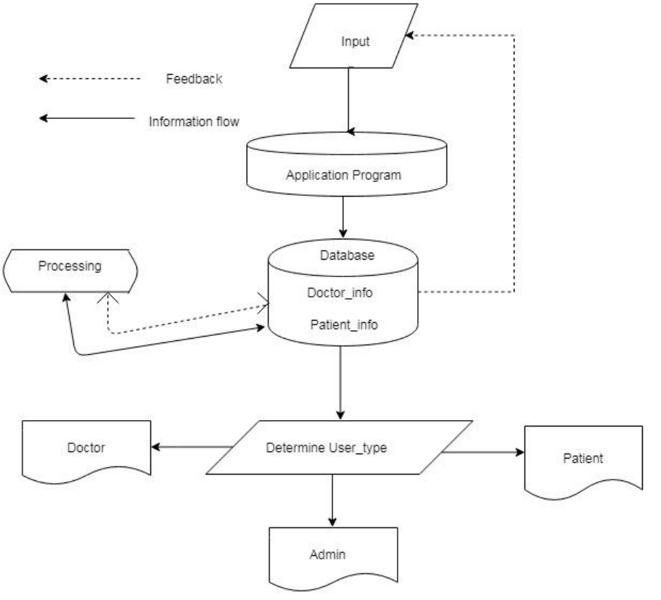

FIGURE 3.1: Information Flow Diagram of Proposed System

**CHAPTER 4**

**SYSTEM DESIGN**

**4.1 Use Case Diagram:**

The use case diagram is used in presenting the system requirements of any proposed system. A use case is a realistic description of the workflow of the system and it is used to explicitly describe the intentions and actions of users. The use case diagram, which present the system requirements are used to show how the proposed system work in practice. The interaction between actor and use cases are also described using use case diagram. The use case diagram of the medical appointment booking system is presented in the following figure. Here some human figures are shown and their activities with the system and also the action they can create. Main functionalities are quite easy here as we focus on friendly user environment.

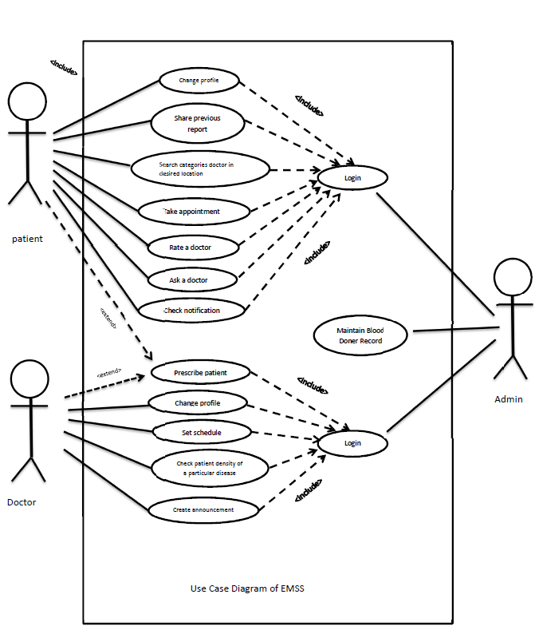

FIGURE 4.1: Use case Diagram of EMSS

**4.2 Class Diagram:**

A class diagram is type of static structure that describes the structure of a system by showing the system’s classes, their attributes, operations (or methods), and the relationships among the classes. In the conceptual model we describe the basic concepts of the system and its relationships with each other. In this point we do not pay much attention to the system behavior. For determining the conceptual model we analyze the administrative, membership, quarry generation, modification tasks of the system. Different functionalities of the system can be accomplished by different classes. If we think about the user, here all the things which are mentioned as (-) sing are known as private and the (+) sign are public. Here users (both doctor and patient) are defined as he/she has to login first then drop his/her information. Patient will perform all the functioned as named and so on doctor. Appointment is the term where doctor and

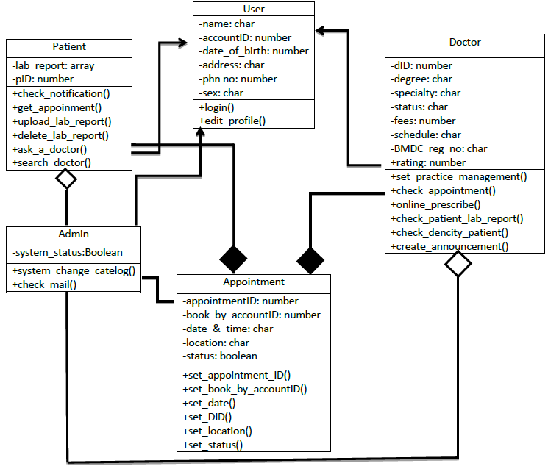

FIGURE 4.2: Class Diagram for EMSS

patient will communicate with each other. Here they all have some common feature. Admin level is for maintenance of the system and taking some attempts in need.

**4.3 Entity Relationship Diagram:**

FIGURE 4.3: Entity Relationship Diagram of EMSS

SCHEDULE

Announcement

LAB Report

Upload

Appoint

SET

DOCTOR

PATIENT

An entity-relationship diagram (ERD) is a graphical representation of an information system that shows the relationship between people, objects, places, concepts or events within that system. An ERD is a data modeling technique that can help define business processes and can be used as the foundation for a relational database. Entities are represented by means of rectangles. Rectangles are named with the entity set they represent. Attributes are the properties of entities. Attributes are represented by means of ellipses. Every ellipse represents one attribute and is directly connected to its entity (rectangle). Relationships are represented by diamond-shaped box. Name of the relationship is written inside the diamond-box. All the entities (rectangles) participating in a relationship, are connected to it by a line. The physical objects of the system; the admins, citizens, and location – corresponding to entities in the Entity-Relationship model, and the operations to be done on those entities – holds, checkouts, and so on – corresponding to relationship. After some considerations, we have decided on the following design, which minimizes the redundancy in the stored information:

**4.4 State Diagram:**

State diagram requires that the system described is composed of a finite number of states; sometimes, this is indeed the case, while at other times this is a reasonable abstraction. It shows how the object transactions from an initial state to other states, when certain events occur or when certain conditions are satisfied. It represents dynamic models of objects which changes their states in response to events. It is a model of the states of an object and the events that cause the object to change from one state to another. Different states can be represented by a rectangle with rounded corners. In figure we have shown different states of citizen info object such as user entrance, insertion form, database accessing, searching result and getting results. It’s easy to find out the activity. Every user should have an account though searching doctor, blog some features are open for all. The next attempt is to checking the validity of a user whether he is a doctor or not and other data are trustworthy or not. Selecting the enchanting task the user goes to the next step, performing the task one can log out from the website or he/she can go for the next task. It’s the almost state diagram from where the tasks are started and where to be stopped. It’s needed for the easiness for making the routing of the system and to handle that in a most efficient way. So state diagram has been started from the login mode and the last task is to log out from the system. Here a state diagram has given which is used to model the dynamic nature of the system and so on.

Perform Task

Select Prescribed Task

Check Valid Id & Password

Take Username & Password

FIGURE 4.4: State Diagram for EMSS.

**4.5 Activity Diagram:**

Activity diagram is basically a flow chart to represent the flow form one activity to another activity. The activity can be described as an operation of the system. The activity at different level of the system can be shown in the following diagram. The facts of the system explained by the following diagram are:

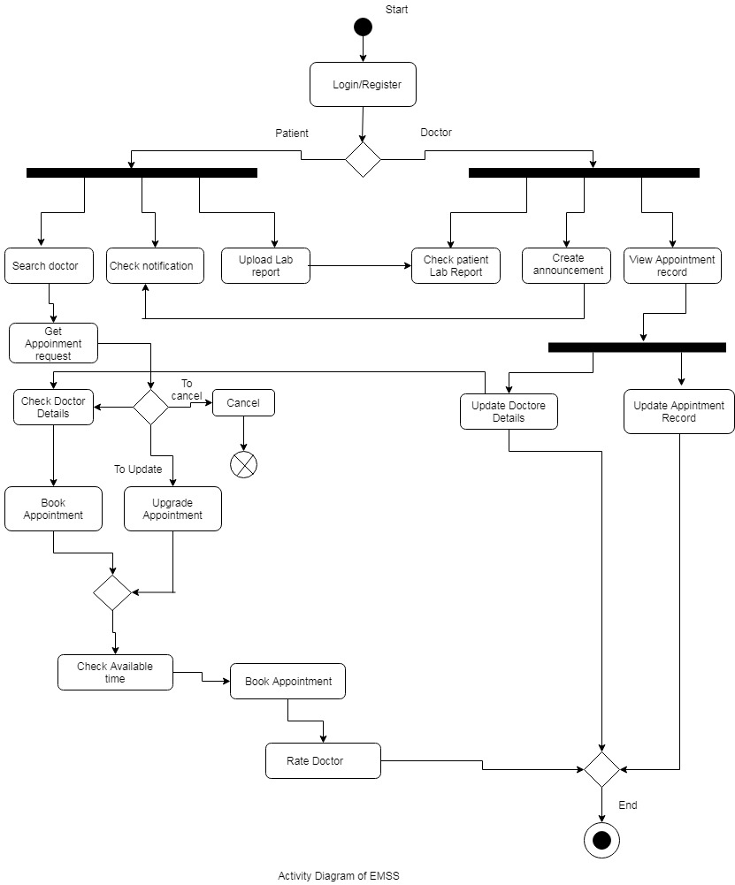

FIGURE 4.5: Activity Diagram of EMSS

1. Every user of the system requires logging in providing valid user name and password.
2. Every patient and doctor has different activities.
3. Patient can perform search doctor, check notification and upload lab report task in parallel. Some features check patient lab report, create announcement. View appointment report can be done parallel.
4. Doctor appointment system is attached with each other, this activity shared by each user.

**CHAPTER 5**

**PARTIAL IMPLEMENTION AND TESTING**

**5.1 Home Page**

Selecting Doctor Category

Doctor Login/Register

Patient Login/Register

Location Search

Menu Option

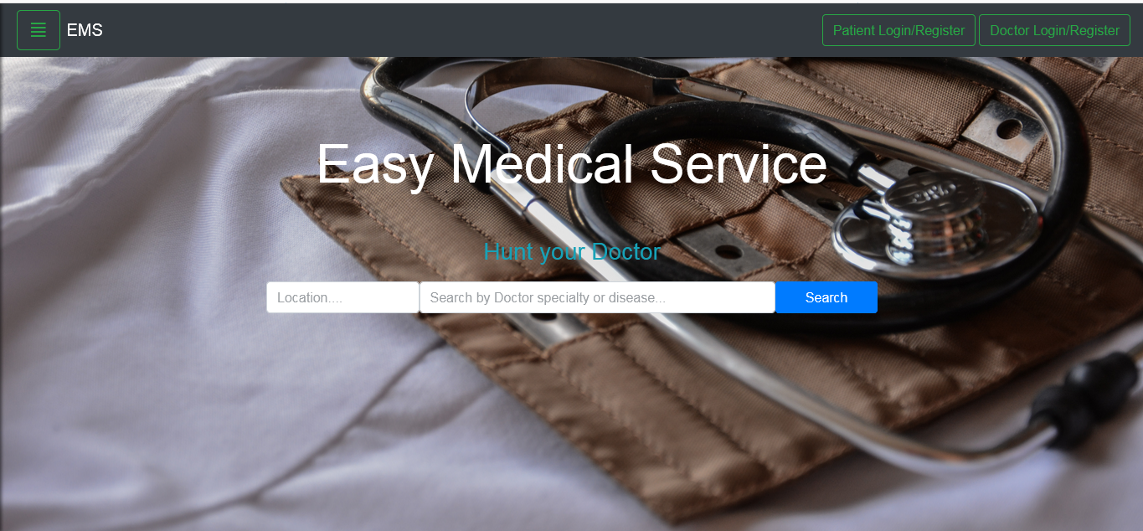

FIGURE 5.1: Home page

While visiting the first page, any user will see this view. Anyone can go to the doctor search option without login having in mind the emergency situation. So for getting all the features first of all, users have to login as patient or as a doctor. In the option menu some features are added for convenience of a user, it’s designed as responsive menu bar for all devices and gadgets. We can communicate with a doctor in the “Ask a Doctor”. In the “Blog" doctors and patients will talk about recent features and also about some disease. “First Aid” is for getting information of having the knowledge of giving first aid to anyone. “Upload Lab Report”, “View Lab Report”, “Delete Lab Report” are only for patient which will be available after login. “Change Setting” is for registered user which will be available after login also. “About” is for getting info of the developer of this project.

Upload Lab Report Option

Recommending First Aid for particular incidence

Read Blog

Mail a Doctor for query manually

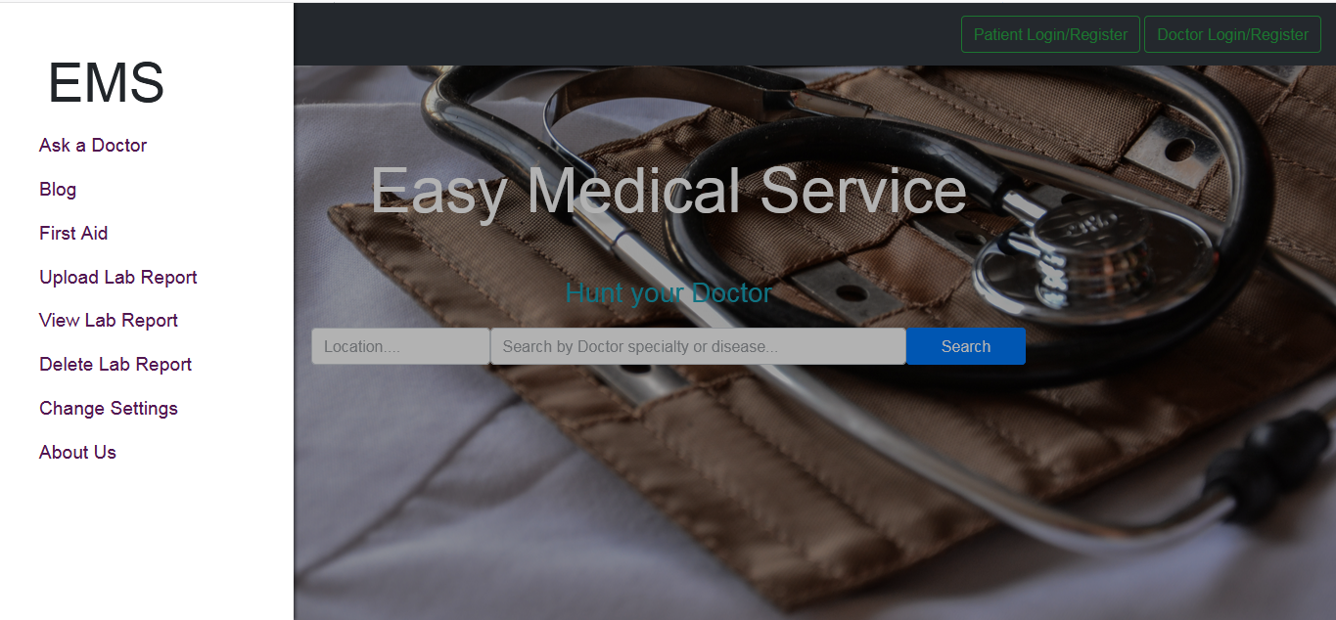

View Lab Report Option

Delete Lab Report Option

Settings Change Option

FIGURE 5.2: Side Bar of Home Page

**5.2 Doctor’s Home Page:**

For Survey Option

Menu Option

For View Patient Details

Profile Picture

For Appointment Creation

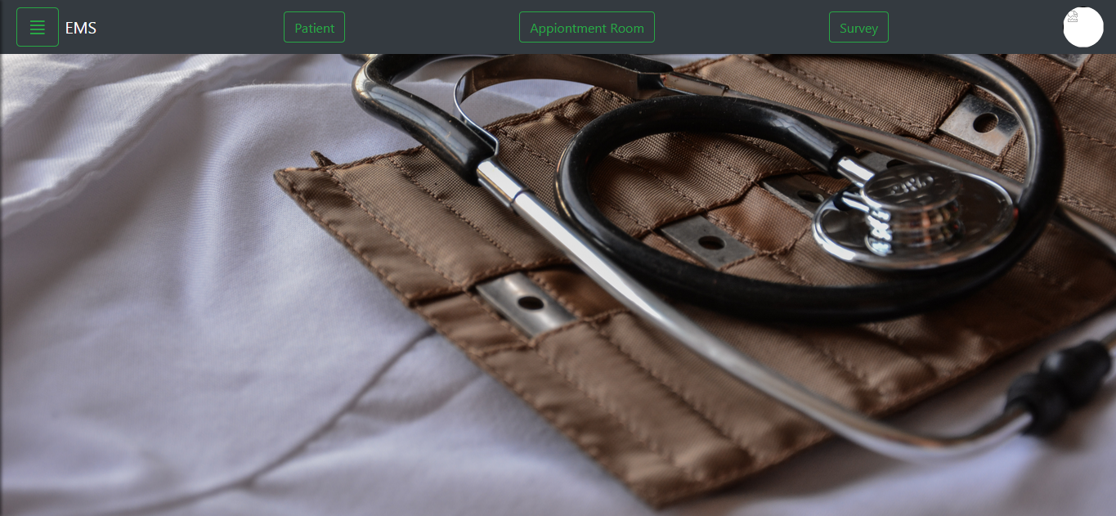

Figure 5.3: Doctor’s Home page

Here we’ll see no change in the background. In toolbar there are four different buttons. All of them are featured as described before. In the sidebar we’ll see some new option’s which are quite different from patient. Here doctors can read a blog and others opinion about it. Only doctors can make a blog about disease and other important health issues problem. “Change settings” is to set the preferences of a doctor and edit their specialization and other details. In the “Survey”, doctors can survey on recent diseases which are now in an epidemic form or patient of particular disease are coming from a particular area. In the appointment box doctors can create their appointment schedule and also can maintain them. Here they’ll set how many patients they’ll deal with and how long. Their tea break time also be shown here.

Read Blog Option

Settings Change Option

Publish Blog Option

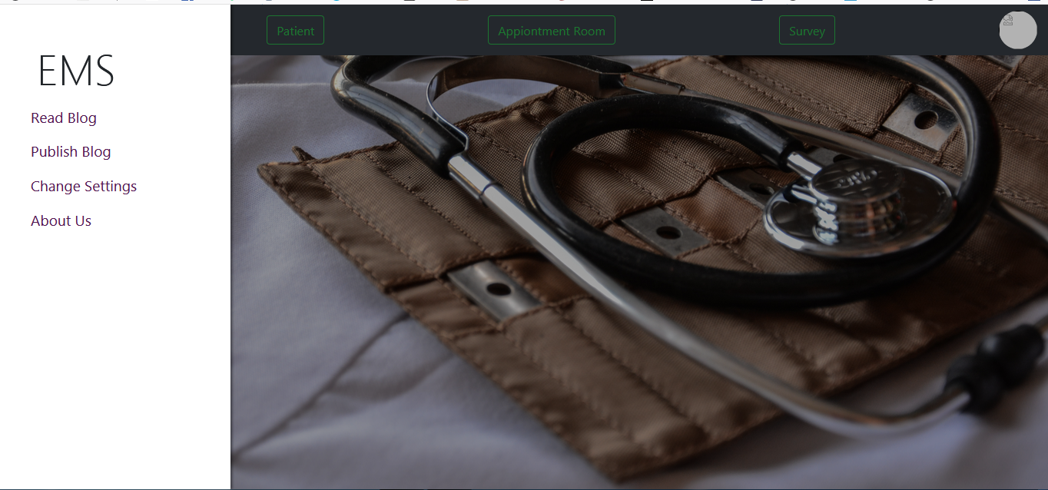

FIGURE 5.4: Doctor’s Side Bar

Survey Box

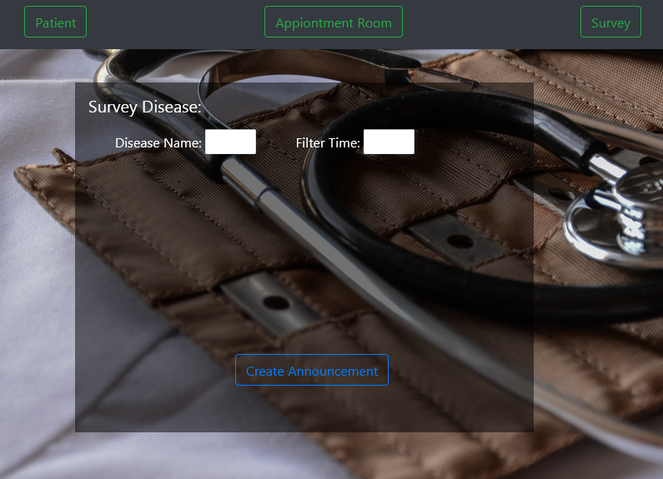

FIGURE 5.5: Doctor’s Disease Survey Feature

Appointment Create Box

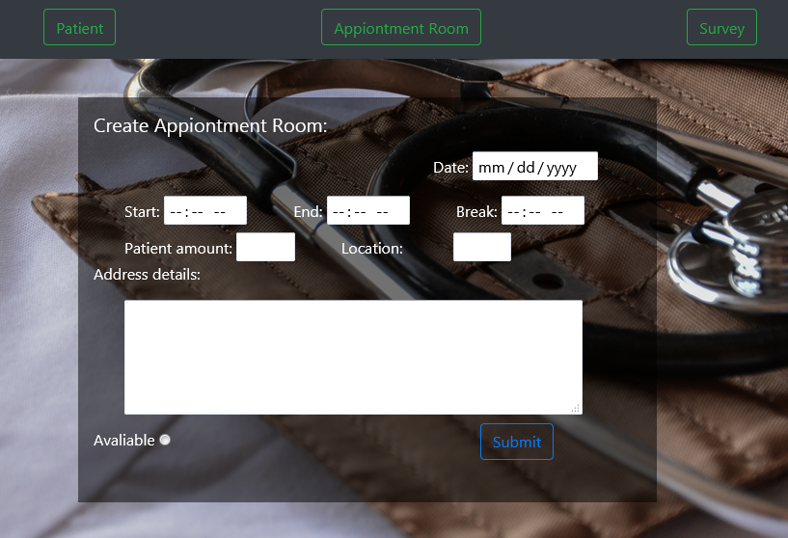

FIGURE 5.6: Doctor’s Appointment Scheduling Feature

**5.3 Mobile view at a glance:**

|  |  |
| --- | --- |
| **p3.PNG** | **p4.PNG** |

|  |  |
| --- | --- |
| p5.PNG | p6.PNG |

FIGURE 5.7: Mobile view

**CHAPTER 6**

**CONCLUSION**

**6.1 Introduction:**

The Easy Medical Service System has been designed and developed aiming to introduce the online platform for medical services in Bangladesh. The proposed system is the initial base for further more technological enhancements in medical field in Bangladesh. One of the prime reasons that Online Patient Scheduling is gaining popularity in recent days is that, the system provides an easier for receiving healthcare facilities to the general users. The project has been proposed an Online Patient Scheduling System built on the Web Service architecture. The prototype of the system would provide the feasibility of the proposed architecture. This case study also provides a preliminary research on the consumers’ acceptance and the functionality of each unit. The system integrates technology of **NODEJS** and **firebase real-time database** development environment.

The aim of this system is to simplify the task of the patient and the doctor. It will surely make the patients more relaxed, because they don’t have to wait in a long queue to book their appointment and also book an appointment according to their choice in a more convenient way. Doctors don’t have to worry about managing their appointment. The doctor is also able to view his day to day appointment list which makes it easier for him/her to plan his/her schedule. Having the cloud system patients can easily go the doctor without having any trouble or thinking, no report will be missed. This helps to save the time and money of patient. Doctors can observe patients’ health’s present condition. This application will help to optimize the work of patient and doctor.

The system is designed to achieve maximum user satisfactory. Since the functionality of online credit card payment is too complex for the developer to implement, only stimulation of the online transaction would be implemented. As the project evaluated, each step of the development process met the system’s objectives and primary user requirements. Certain enhancements could be suggested for the system in future is to integrate actual online payment\ transaction, SMS integrated and implementing Artificial Intelligence features that could make this EMSS system a more automated in management system.

**6.2 Future Plan:**

The developed project might have certain drawbacks because of insufficient time and lack of resources. If we would have sufficient time we could cover those drawbacks. We will try to upgrade this project and extend the following features:

Currently our service is available only in the web page form though we designed it for mobile view also. But we would like to upgrade our project so that Smartphone users of all platforms (windows, IOS, Android etc.) can be benefited with our project.

For searching we would like to add phonetic algorithm so that misspelling will not cause any harm for searching a doctor. The web page can be made more light so that with low internet speed that page can be browsed.